
FACULITY OF INFORMATION AND COMMUNICATION TECHNOLOGY

PROG 102– PRINCIPLES OF SOFTWARE ENGINEERING
TITLE: DESIGN A DIGITAL PUBLIC GOOD SYSTEM
DUE DATE: WEEK 4
LECTURER: MR. SANTIGIE FODAY KAMARA
CLASS: BSEM 1203F
SEMESTER/YEAR: SEMESTER 2
Academic Honesty Policy Statement

We, hereby attest that contents of this attachment are my own work. Referenced works, articles, art, programs, papers or parts thereof are acknowledged at the end of this paper. This includes data excerpted from CD-ROMs, the internet, other private networks, and other people’s disk of the computer system.

NO | NAMES | ID Number | SIGNATURE | MARKS
1 | Zeyad Mohamed Zaki Ezzeldin Elgabry | 905005887
2 | Hashiatu Nyallay | 905005936
3 | Gleekan David Williams | 905005907

Student’s Signatures: Date: 27/04/26

MENTOR’S COMMENTS/GRADE:

for office use only upon receiving
Remark

DATE :
TIME :
RECEIVE

Table of Contents
Abstract 2
Introduction 3
Problem Definition 4
Use Case Diagram 7
System Description 9
SDG Link 15
Conclusion 18
References 19

Abstract
The increasing demand for rental housing in Sierra Leone has exposed significant inefficiencies in the property search process. Tenants often incur high costs and wasted time due to duplicate listings, unverified properties, and unstructured communication with agents and landlords. Similarly, landlords struggle to reach suitable tenants, while agents operate without coordinated systems.
This project proposes RentSure, a verified rental coordination system that ensures each property is uniquely listed and managed through a structured workflow. The system enables tenants to search for verified properties and request scheduled viewings, while landlords and agents manage listings and approve viewing requests. By eliminating duplication and introducing controlled interactions, the platform reduces costs, improves trust, and enhances overall efficiency for all stakeholders in the rental market.

Introduction
The rental housing sector in Sierra Leone operates largely within an informal framework, where property listings are dispersed across multiple agents, social networks, and physical visits. This fragmented system creates inefficiencies, including duplicate listings, unreliable property information, and high costs for tenants seeking accommodation.
With the advancement of information technology, there is an opportunity to digitize and structure this process. However, existing solutions often fail to address the root issues of duplication, trust, and coordination.
This project introduces a rental coordination platform designed to centralize property listings, enforce uniqueness, and facilitate structured viewing requests. By focusing on simplicity and usability, the system aims to improve accessibility and efficiency for tenants, landlords, and agents.

Problem Definition
Background of the Problem
The rental housing system in Sierra Leone operates largely in an informal and unstructured manner. Property listings are commonly shared through word-of-mouth, roadside agents, and messaging platforms such as WhatsApp. As a result, there is no centralized or reliable database of available rental properties.
One of the most significant issues in this system is the duplication of property listings. The same property is often advertised by multiple agents, each presenting it as a separate listing. This lack of coordination leads to confusion and inefficiency in the property search process.
Additionally, tenants are required to physically visit properties before making decisions. This process involves paying viewing fees and transportation costs, often for properties that may already be rented out, inaccurately described, or duplicated under different agents. The absence of structured scheduling further complicates coordination between tenants, landlords, and agents.

Who is Affected (Target Users)
The problem impacts three primary groups:
1. Tenants
Tenants are the most affected, as they:
- Spend significant money on transport and viewing fees
- Waste time visiting duplicate or unavailable properties
- Struggle to find accurate and verified property information

2. Landlords
Landlords face challenges such as:
- Limited visibility of their properties
- Dependence on multiple agents to find tenants
- Difficulty identifying serious and reliable tenants

3. Agents
Agents operate in an unstructured environment where they:
- Compete by listing the same property multiple times
- Lack digital tools to manage listings efficiently
- Spend excessive time coordinating physical viewings

Why the Problem is Important
This problem is important because it directly affects cost, efficiency, and trust in the housing market.
- Financial Burden on Tenants
Tenants incur unnecessary expenses due to repeated viewings, transport costs, and duplicated listings. This increases the overall cost of securing housing.
- Inefficiency in the Rental Process
The lack of a centralized and structured system results in wasted time for all parties involved. Transactions take longer to complete, and opportunities are often missed.

- Lack of Trust and Transparency
Without verification, tenants cannot confidently rely on property information. This discourages the use of digital platforms and reinforces dependence on informal methods.
- Limited Market Optimization
Landlords and agents are unable to maximize property visibility and efficiency due to fragmented listing systems.

Summary
The absence of a centralized, verified, and structured rental system leads to duplication, high costs, inefficiency, and lack of trust. Addressing this problem is essential to improving the overall rental experience for tenants, landlords, and agents, and to modernizing the housing market through technology.

Use Case Diagram

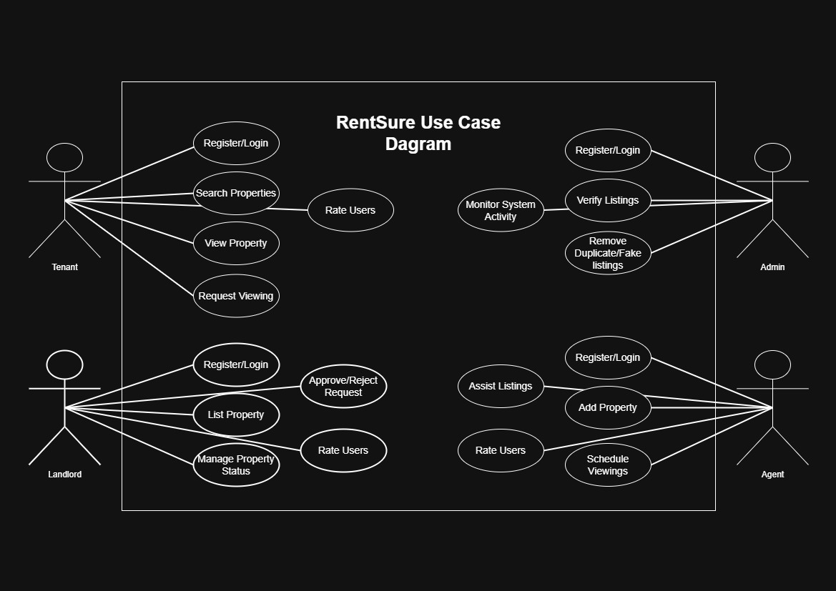

The RentSure system consists of four main actors: Tenant, Landlord, Agent, and Admin. Tenants can search for properties, view details, request viewings, and rate users after interactions. Landlords are responsible for listing properties, managing property status, and approving or rejecting viewing requests. Agents assist in adding and managing property listings as well as scheduling viewings. The Admin monitors system activity, verifies listings, and removes duplicate or fake properties to ensure system integrity. The system operates within a defined boundary where all interactions are controlled through structured use cases to improve efficiency, trust, and coordination in the rental process.

UML Diagram

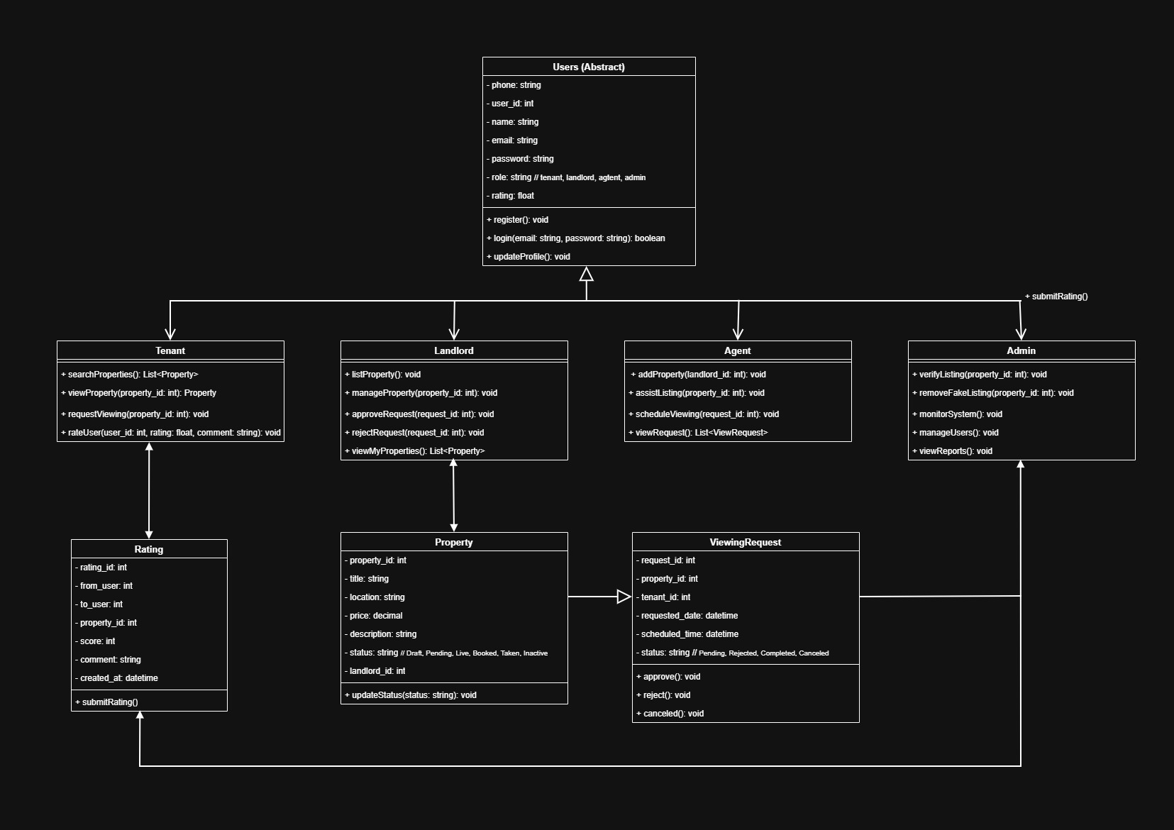

The RentSure system is designed using an object-oriented approach where all users inherit from a general Users (Abstract) class. The system is divided into four main roles: Tenant, Landlord, Agent, and Admin, each with specific responsibilities. Properties are centrally managed and linked to landlords, while tenants interact through viewing requests. The system also includes a rating mechanism to promote trust and accountability between users. The ViewingRequest class handles scheduling and approval of property viewings, ensuring structured communication within the platform.

System Description
System Name
RentSure: A Verified Rental Coordination System

Purpose of the System
The purpose of RentSure is to provide a centralized and structured platform for managing rental property listings and coordinating property viewings. The system is designed to eliminate duplicate listings, reduce the cost and effort required for property searches, and improve trust among tenants, landlords, and agents.
By ensuring that each property is uniquely listed and by replacing unstructured communication with a controlled viewing request system, the platform aims to make the rental process more efficient, transparent, and reliable.

Key Features / Functions
1. Unique Property Listing
- Each property is listed only once in the system
- Duplicate detection prevents multiple listings of the same property
- Properties are verified before becoming visible

2. Property Search and Filtering
- Tenants can search for properties based on:
  - Location
  - Price
  - Availability
- Displays only verified and active listings

3. Viewing Request System
- Tenants request to view a property through the platform
- Landlords or agents can accept or reject requests
- Eliminates the need for direct, unstructured communication

4. Property Status Management
Each property is tracked using defined states:
- Draft
- Pending Verification
- Live
- Booked
- Taken
- Inactive
This ensures clarity on availability at all times.

5. Role-Based Access
- Tenants: Search properties and request viewings
- Landlords: List and manage properties
- Agents: Assist in listing properties and coordinating viewings

6. Ratings and Feedback System
- Users can rate each other after interactions
- Encourages accountability and builds trust

How Users Will Interact With the System
Tenants
- Register and log in
- Search and browse available properties
- View property details (images, price, location)
- Request viewing appointments
- Receive confirmation or rejection
- Rate the experience after viewing

Landlords
- Register and log in
- List new properties or approve agent submissions
- Monitor incoming viewing requests
- Accept or reject viewing requests
- Update property status

Agents
- Register and log in
- Add properties on behalf of landlords
- Assist in uploading property details and images
- Help coordinate viewing schedules

Expected Benefits
For Tenants
- Reduced transport and viewing costs
- Faster and more efficient property search
- Access to verified and accurate listings

For Landlords
- Increased visibility of properties
- Access to serious and pre-qualified tenants
- Reduced time spent managing inquiries

For Agents
- Better organization of listings
- Increased chances of closing deals
- Ability to build reputation through ratings

For the System (Platform)
- Generates revenue through structured viewing requests
- Builds a trusted and scalable property database
- Positions itself as a reliable housing solution

Basic Workflow (Step-by-Step Process)
Step 1: User Registration
All users (tenants, landlords, agents) create accounts and log into the system.

Step 2: Property Listing
- Landlords or agents add a property
- System checks for duplicates
- Property is verified and set to “Live”

Step 3: Property Search
- Tenants search and filter properties
- View details of selected listings

Step 4: Viewing Request
- Tenant submits a viewing request
- Selects preferred date and time

Step 5: Request Management
- Landlord or agent reviews the request
- Accepts or rejects the request

Step 6: Property Viewing
- Tenant visits the property at the scheduled time

Step 7: Rating and Feedback
- Tenant rates landlord/agent
- Landlord/agent may rate tenant

Step 8: Property Status Update
- Once rented, property status changes to “Taken”
- Listing becomes unavailable to other tenants

Summary
The RentSure system introduces a structured, efficient, and trustworthy approach to rental property management. By centralizing listings, enforcing uniqueness, and streamlining interactions through viewing requests, the system significantly improves the rental experience for all stakeholders.

SDG Link
Supported Sustainable Development Goal (SDG)
The proposed system, RentSure: A Verified Rental Coordination System, primarily supports:
United Nations Sustainable Development Goal 11: Sustainable Cities and Communities
Goal 11 aims to make cities inclusive, safe, resilient, and sustainable by improving access to adequate, safe, and affordable housing and basic services.

How the System Contributes to the SDG
1. Improving Access to Housing Information
The system provides a centralized platform where tenants can easily search for available rental properties. By organizing property data in one place, it reduces the difficulty of finding housing, especially in urban areas.
Contribution:
- Makes housing information more accessible and transparent
- Supports inclusive access to accommodation opportunities

2. Reducing Financial Burden on Tenants
Tenants often spend money on transportation and repeated viewing fees due to duplicate and unverified listings. The system eliminates duplication and ensures that only valid listings are displayed.
Contribution:
- Lowers the cost of searching for housing
- Supports affordability, especially for low- and middle-income individuals
3. Enhancing Efficiency in Urban Housing Systems
The introduction of structured viewing requests replaces informal and uncoordinated interactions. This improves the efficiency of how rental transactions are conducted.
Contribution:
- Reduces time wasted in the housing search process
- Improves coordination between tenants, landlords, and agents

4. Promoting Transparency and Trust
The system includes verified listings and a rating mechanism that allows users to evaluate each other. This increases accountability and reduces fraudulent or misleading practices.
Contribution:
- Builds trust in the housing market
- Encourages fair and transparent transactions

5. Supporting Digital Transformation of Informal Systems
The rental market in many developing regions operates informally. This system introduces a digital structure that formalizes processes without removing key participants like agents.
Contribution:
- Strengthens urban infrastructure through technology
- Encourages innovation in housing management

Additional SDG Alignment (Secondary)
SDG 9: Industry, Innovation, and Infrastructure
- The system introduces a digital platform that improves infrastructure in the housing sector
- Encourages innovation in property management and service delivery

SDG 1: No Poverty
- By reducing unnecessary expenses in the housing search process, the system helps individuals retain more of their income
- Improves access to affordable housing opportunities

Summary
The RentSure system directly contributes to achieving SDG 11 by improving access to housing, reducing costs, and enhancing efficiency in the rental market. Through digital innovation, the system addresses key challenges in urban housing and promotes a more inclusive, transparent, and sustainable community.

Conclusion
The RentSure: A Verified Rental Coordination System was developed to address the inefficiencies and challenges present in the traditional rental housing market. The current system is characterized by duplicate property listings, high search costs for tenants, lack of centralized information, and unstructured communication between tenants, landlords, and agents.
This project introduces a structured digital solution that ensures each property is uniquely listed and verified before being made available to tenants. By replacing informal communication with a controlled viewing request system, the platform reduces confusion, minimizes wasted time, and improves coordination among all stakeholders.
The system also enhances trust through role-based access and a rating mechanism, allowing users to evaluate their experiences and improve accountability within the rental ecosystem. Furthermore, it contributes to sustainable urban development by improving access to housing information and reducing unnecessary financial burdens on tenants.
Overall, RentSure demonstrates how technology can be used to transform informal housing systems into efficient, transparent, and user-friendly digital platforms that benefit society as a whole.

References
- United Nations. (2015). Sustainable Development Goal 11: Make cities and human settlements inclusive, safe, resilient and sustainable. Available at: https://sdgs.un.org/goals/goal11
- United Nations. (2015). Sustainable Development Goals Report. United Nations Publications.
- Limkokwing University of Creative Technology – Sierra Leone. (2026). PROG102: Principles Of Software Engineering Assignment Brief. Faculty of Information and Communication Technology.
- Limkokwing University of Creative Technology – Sierra Leone. (2026). PROG102 Lecture Notes and Class Materials. Faculty of Information and Communication Technology.
- Limkokwing University of Creative Technology – Sierra Leone. (2026). Software Development Life Cycle (SDLC) Lecture Slides. Faculty of Information and Communication Technology.

